**Developer Responsibilities**

Data Base: - SQL Server.

Application in ASP.NET core & C#.Net under Visual Studio.

**Database Structure**

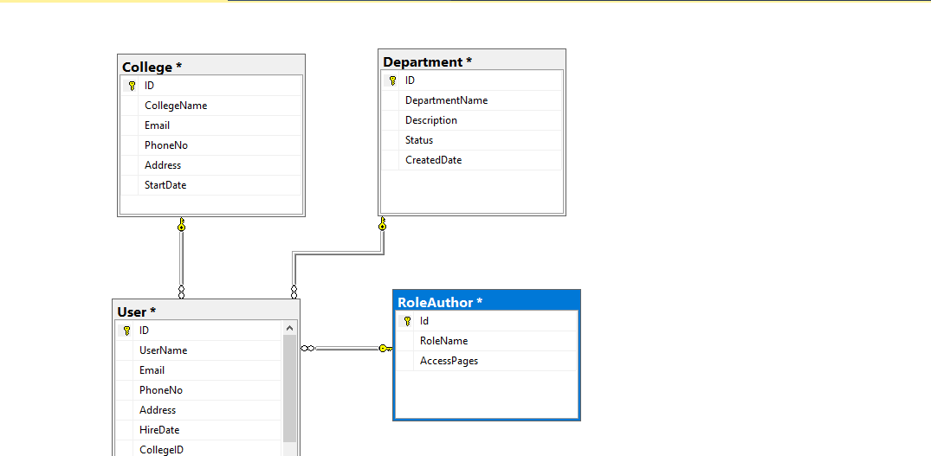

In database we are using 4 tables for our web app.

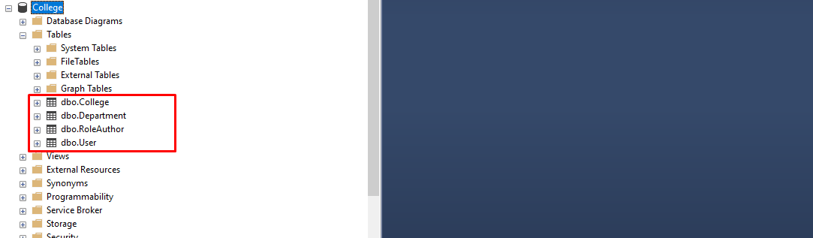

1. **College table**

In college table we are saving college information



1. **Department table**

In Department table we are saving department information

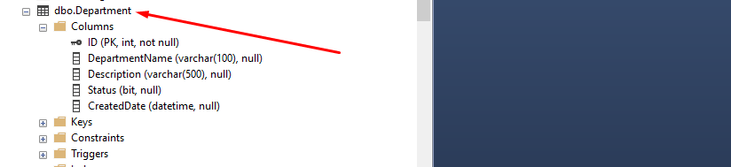

1. **Role Author table**

In Role Author table we are saving Application user role



1. **User table**

In User table we are saving Application user information



**Login Screen**

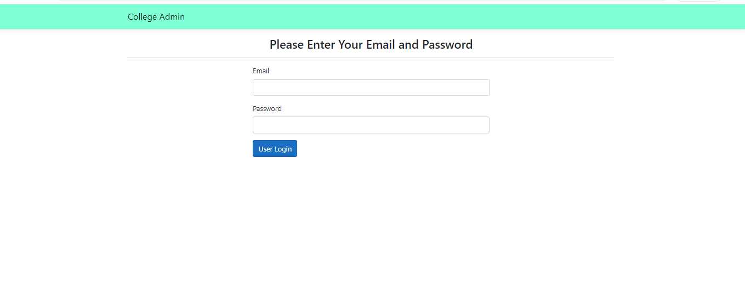

Login screen help to login valid user with using their email address and password and use our application.

**First look**



After login with valid username and password user redirect to dashboard screen. Where all the tabs are visible to user according to your role.

**College List**

All the colleges are list out here with their information.

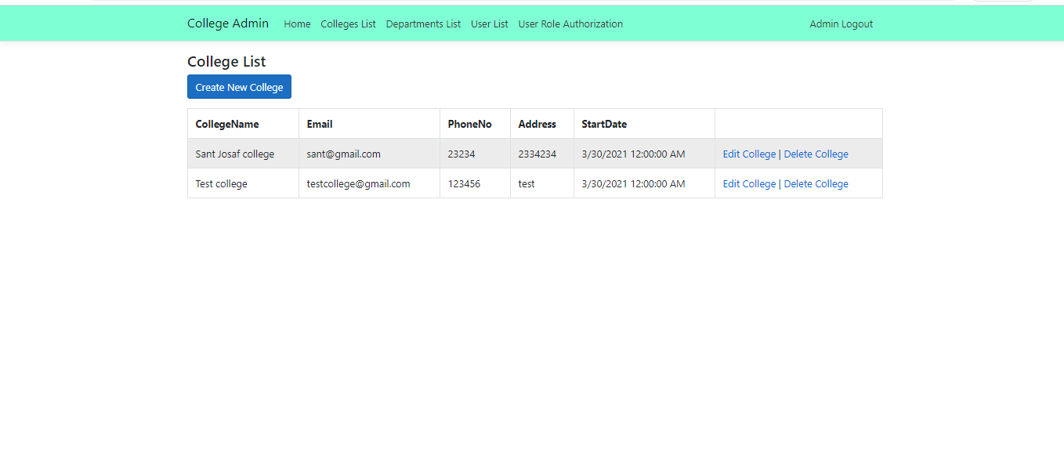

**Create College**

In this form we are fill all the college information and save in our database.

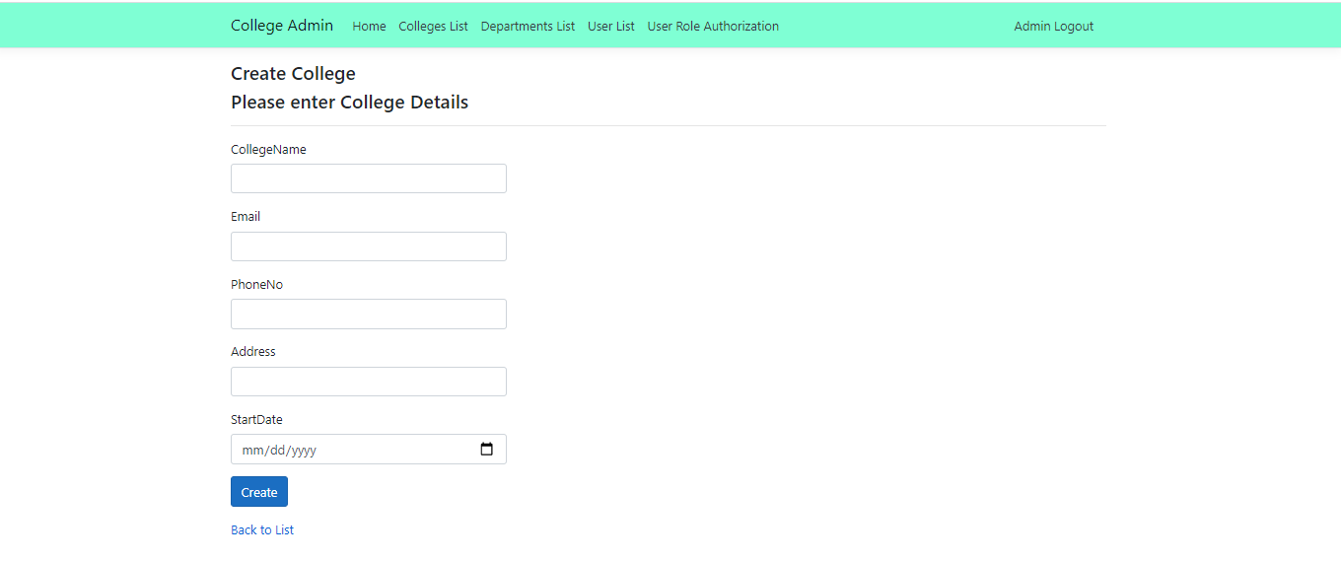

**Department List**

In this page we are showing the department list as per entered by users or admin.

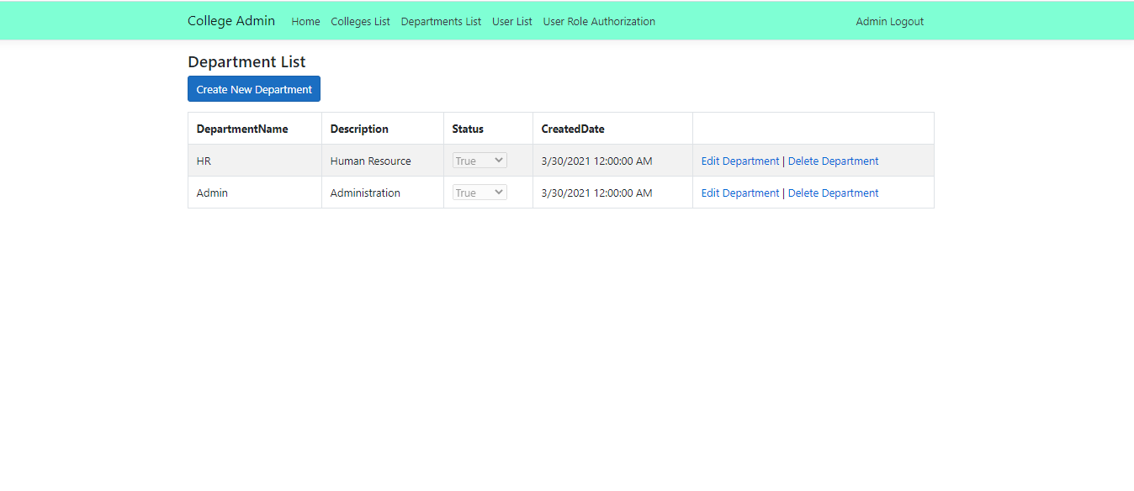

**Create Department**

Creating departments according to college requirements which are associated with our web app.

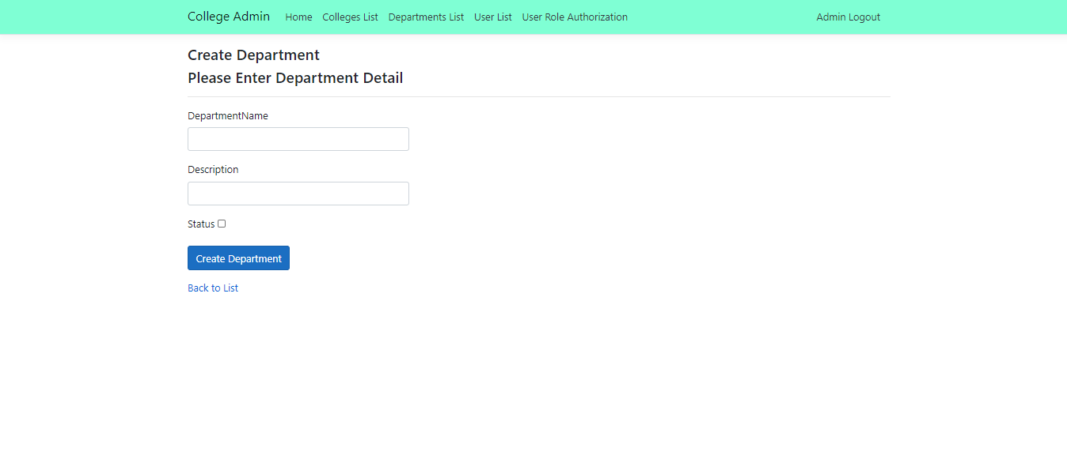

**User List**

All the employees and users are list out here according to their role and department.

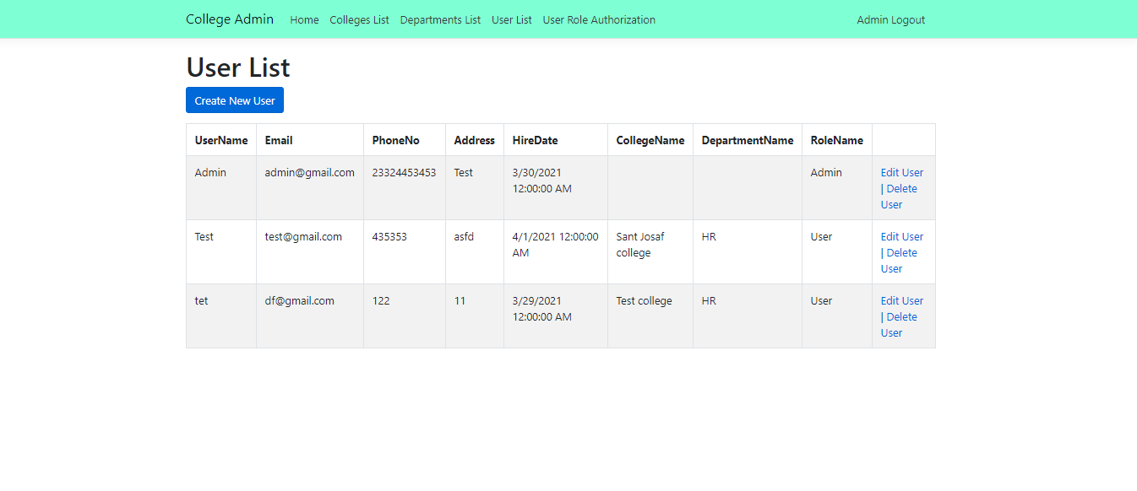

**Create User**

Creating Users according to college and department and assign role to while saving the user information in our application.

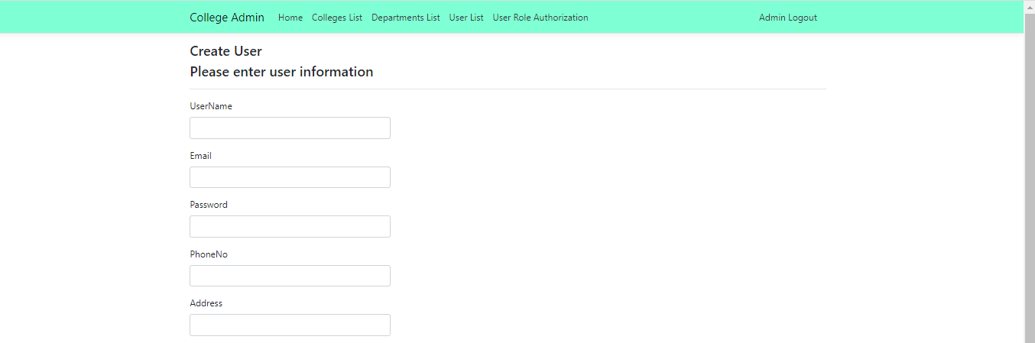

**Role List**

List of all the Roles created by valid user and admin.

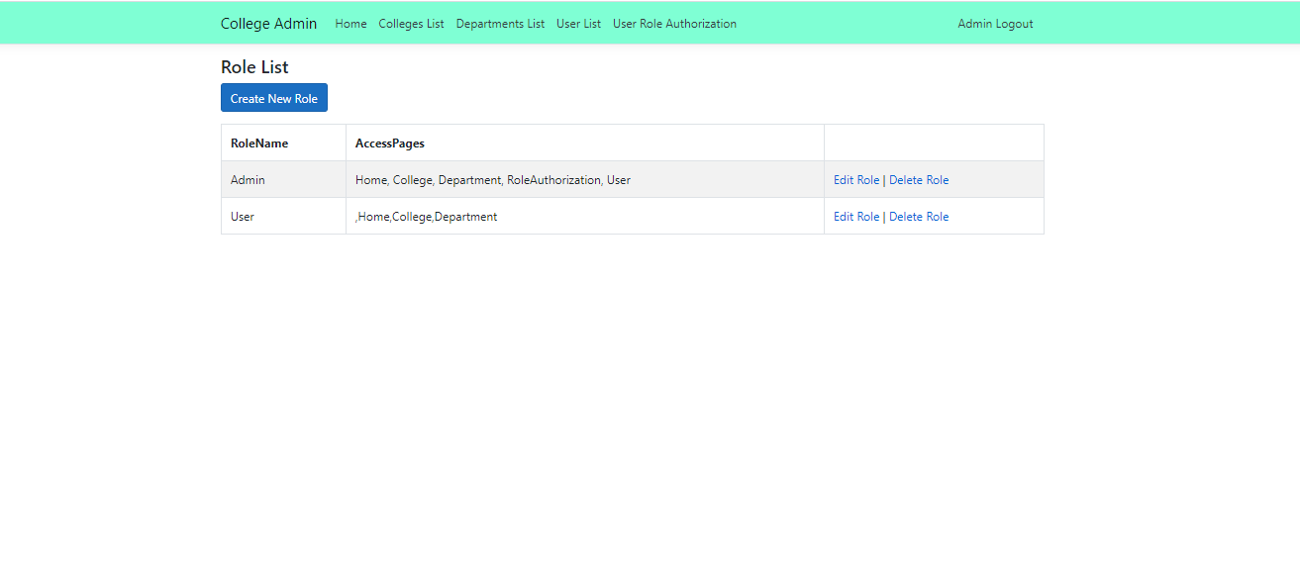

**Create Role**

Here we creating role and assign the pages to that role.

